Chapter 2
Creating Web Forms Applications
About This Chapter
In this chapter, you’ll learn how to create an ASP.NET Web application using Microsoft Visual Studio .NET and ASP.NET. You’ll learn how to start a new project, create a basic user interface, write code to respond to events, and preserve data within your application. Because ASP.NET is integrated with Microsoft Internet Information Services (IIS), you’ll also learn about IIS and how to use it to organize your Web application.
Before You Begin
To complete the lessons in this chapter, you must:
- Have installed Visual Studio .NET, IIS, and the Microsoft FrontPage Server Extensions on your computer.
- Be familiar with the basics of using Visual Studio .NET, including how to add controls to a Microsoft Windows form, how to add code to controls, and how to run an application within Visual Studio .NET. See the QuickStart tutorials included with Visual Studio .NET for instructions on these tasks.
Lesson 1: Creating an ASP.NET Web Application Project
Web forms are the application objects that define the user interface of your Web application. The text and controls you place on a Web form determine what a user sees when he or she runs your application. In this way, Web forms are similar to Windows forms in a Windows application.
Unlike Windows applications, however, Web applications run on a server and are distributed to clients through the Internet. Therefore, how you create and organize a Web application project has significant differences from working with Windows applications in Visual Studio .NET. These differences are explained in the following sections.
After this lesson, you will be able to
- Start a Web Forms project in Visual Studio .NET
- Set the physical location where your projects will be stored
- Add server controls to a Web form and write code to respond to events on those controls
- Run the Web application in the programming environment
- Identify the purpose of the files in a Web Forms project
Estimated lesson time: 30 minutes
Creating a New Web Application
The first step in creating an ASP.NET Web application is to start a new project in Visual Studio .NET. Visual Studio .NET provides templates for each type of application you can create. The template for a Web application is named ASP.NET Web Application. When you create a new project using this template, Visual Studio .NET creates a project file; a new, blank Web form; and other supporting files used by your application.
To create a Web application project from Visual Studio .NET, follow these steps:
- On the Visual Studio .NET Start Page, click New Project. Visual Studio .NET displays the New Project dialog box, as shown in Figure 2-1. Visual Studio .NET puts Web applications in the localhost virtual directory.
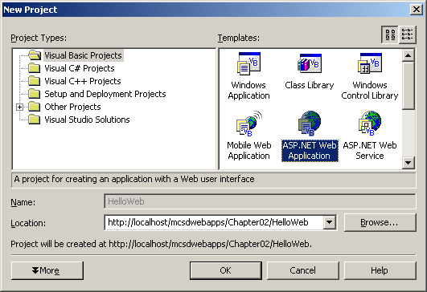
Figure 2-1. The New Project dialog box
- In the New Project dialog box, select the ASP.NET Web Application template, type the name of the new project in the Location text box, and click OK.
When you create a Web application project in Visual Studio .NET, the programming environment creates a new folder and generates a set of files for the project. Visual Studio .NET gives the folder the same name as the project and puts the folder in the root folder of the default Web site that IIS hosts on your computer. This location is shown in the Location box of the New Project dialog box as http://localhost/projectname.
Organizing Your Projects with IIS
It’s important to realize that Web applications can exist only in a location that has been published by IIS as a virtual folder. A virtual folder is a shared resource identified by an alias that represents a physical location on a server. If you try to select a physical folder from the New Project dialog box, such as C:\MyFiles, Visual Studio .NET disables the OK button. It’s not OK—you can’t create a Web application there!
The virtual folder named //localhost is the Web root folder on your computer. IIS determines the physical location of your Web root folder. By default, IIS installs the folder on your boot drive at \Inetpub\wwwroot. Instead of using the //localhost default and letting it get cluttered with sample projects, production code, and other stuff, organize your projects by creating separate folders for samples, tests, and production code. Then share those folders with the Web before you create new projects. Remember that Visual Studio .NET creates a new folder for each new project, so create only the folders you need to organize the types of projects you create.
Creating Virtual Folders to Organize Web Applications
Use IIS to create new virtual folders and to manage Web sites hosted on your computer. Creating a virtual folder for use with Visual Studio .NET requires two major tasks:
- Creating the virtual folder.
Virtual folders specify where your Web application projects are physically stored, so you use them to help organize your projects during development.
- Adding the FrontPage Server Extensions to the virtual folder to create a subweb.
A subweb is simply a virtual folder that contains a Web site. Adding the FrontPage Server Extensions to a virtual folder enables Visual Studio .NET to create and maintain Web applications in that folder.
Creating a Virtual Folder
To create a new virtual folder in IIS, follow these steps:
- Open the IIS management console by clicking Start, pointing to All Programs, Administrative Tools, and clicking Internet Information Services.
- In the console tree, expand the local computer and Web sites. Right-click Default Web Site, point to New, and click Virtual Directory on the shortcut menu, as shown in Figure 2-2. The Virtual Directory Creation Wizard opens.
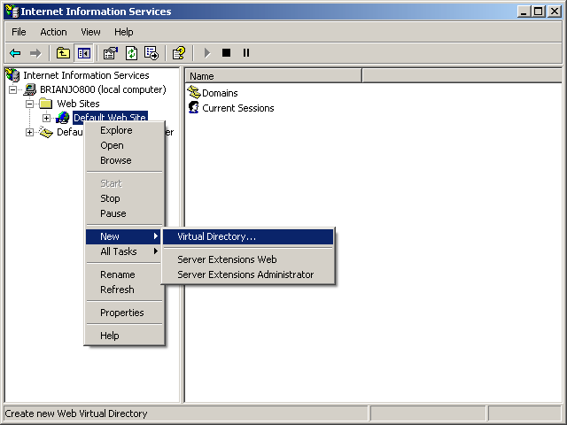
Figure 2-2. Creating a new virtual folder
- IIS starts the Virtual Directory Creation Wizard to walk you through creating a new virtual folder. Click Next on the wizard title page to display the Virtual Directory Alias page, as shown in Figure 2-3.
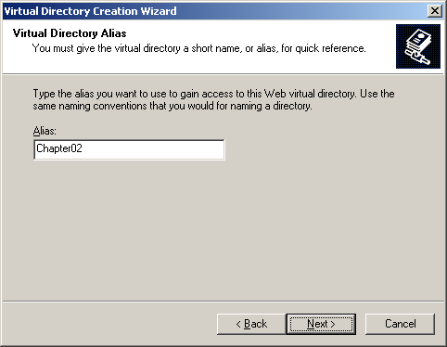
Figure 2-3. The Virtual Directory Alias page
- Type an alias for the folder. The alias is the name you will use to identify the resource in this folder. In Visual Studio .NET, this is the name you will use to specify the location of your project. Click Next. The wizard displays the Web Site Content Directory page, as shown in Figure 2-4.
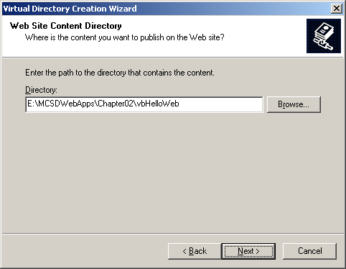
Figure 2-4. The Web Site Content Directory page
- In the Directory box, type the path specification of the physical folder to associate with the virtual folder. This is the base folder where your project folders will be stored. Click Next. The wizard displays the Access Permissions page, as shown in Figure 2-5.
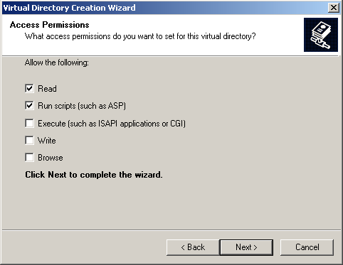
Figure 2-5. The Access Permissions page
- Keep the default permissions shown in Figure 2-5. Click Next and then click Finish to create the virtual folder and complete the wizard.
Creating a Subweb
To add the FrontPage Server Extensions to a virtual folder, follow these steps:
- Right-click the Default Web Site icon in the IIS management console, point to New, and click Server Extensions Web on the shortcut menu.
- IIS starts the New Subweb Wizard to walk you through adding the FrontPage Server Extensions to your virtual folder. Click Next on the wizard title page to display the Subweb Name page, as shown in Figure 2-6.
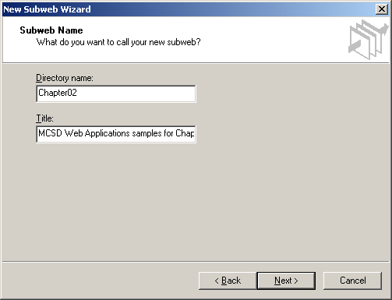
Figure 2-6. The Subweb Name page
- Type the name of the virtual folder in the Directory Name box. This name corresponds to the alias you entered in step 4 of the previous procedure. Type a description of the folder in the Title box or leave it blank. Click Next. The wizard displays the Access Control page, as shown in Figure 2-7.
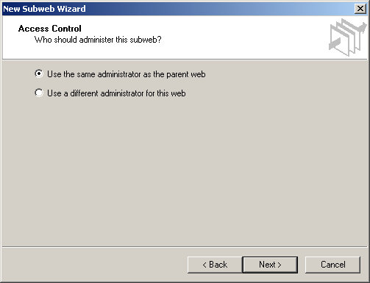
Figure 2-7. The Access Control page
- Accept the default access control settings by clicking Next, and then click Finish to create the subweb.
Creating a New Project in the Virtual Folder
After you create a new virtual folder and add the server extensions to it, you can use it within Visual Studio .NET to create new projects. To create a Web application project in your new virtual folder, choose New Project from the Visual Studio .NET File menu, and specify the name of the virtual folder in the New Project dialog box, as shown in Figure 2-8.
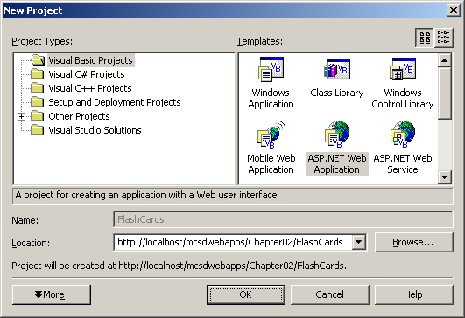
Figure 2-8. Create a Project in the new virtual folder
The location you specify in the New Project dialog box takes the form http://servername/virtualfolder. The server name localhost indicates that the server is running on your development machine. The name virtualfolder is the alias you created for the virtual folder in the preceding tasks.
Adding Controls and Writing Code
When Visual Studio .NET creates a Web application, it displays a new Web form in the center window, as shown in Figure 2-9. Drag controls from the Toolbox to the Web form as you would with a Windows form.
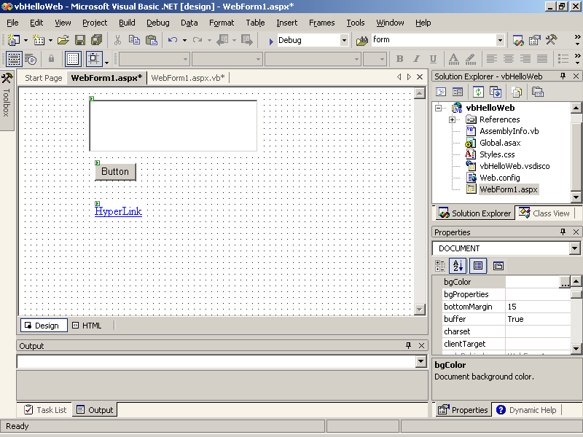
Figure 2-9. A new Web form
To add code to respond to events on the Web form, double-click the control. Visual Studio .NET displays the Code window. Add your code to the event procedure provided for the control. For example, the following code displays Hello, Web! in Internet Explorer when you click the Button1 command button:
Visual Basic .NET
Private Sub Button1_Click(ByVal sender As System.Object, _
ByVal e As System.EventArgs) Handles Button1.Click
Response.Write("Hello, Web!<br>")
End Sub
Visual C#
private void Button1_Click(object sender, System.EventArgs e)
{
Response.Write("Hello, Web!<br>");
}
Visual Studio automatically creates the event procedures for an object’s default event when you double-click the control in the Design window. The Button1_Click event procedure shown above responds, or handles, the Click event for the Button control. In Microsoft Visual Basic .NET, the Handles clause at the end of the procedure declaration makes the connection between the Click event and this event procedure.
In Microsoft Visual C#, this connection is hidden in the code generated by the Web Forms Designer. To view this code, click the plus sign next to the Web Form Designer Generated Code region in the Code window. The following code shows the generated code connecting the Form Load event and Button Click events to event procedures.
Visual C#
#region Web Form Designer generated code
override protected void OnInit(EventArgs e)
{
//
// CODEGEN: This call is required by the ASP.NET Web Form Designer.
//
InitializeComponent();
base.OnInit(e);
}

/// <summary>
/// Required method for Designer support - do not modify
/// the contents of this method with the code editor.
/// </summary>
private void InitializeComponent()
{
this.Button1.Click += new System.EventHandler(this.Button1_Click);
this.Load += new System.EventHandler(this.Page_Load);
}
#endregion
Creating this connection between an object’s event and the event procedure that responds to the event is called wiring the event. Visual Basic .NET automatically creates this connection through the Handles clause, but Visual C# requires you to wire the event manually by adding code to the InitializeComponent procedure for any of the nondefault events you want to use.
To run the application, press F5. Visual Studio .NET builds the application, starts the browser, and then displays the page in the browser. When you click Button1, the browser displays Hello, Web! as shown in Figure 2-10. Closing the browser ends the Web application.
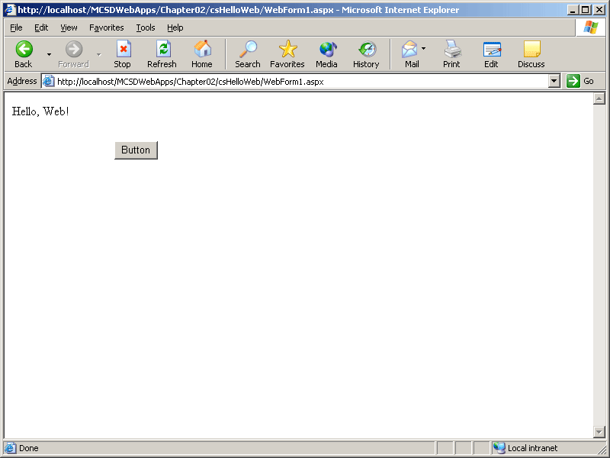
Figure 2-10. The Web form
As you can see from this example, Web Forms applications are similar to Windows Forms applications. However, Web Forms applications have the following significant differences:
- Tools.
Web forms can’t use the standard Windows controls. Instead, they use server controls, HTML controls, user controls, or custom controls created specially for Web forms.
- User interface.
The appearance of a Web form is determined by the browser that displays it. Your Web application can appear in Internet Explorer, Netscape Communicator, or any other HTML-compliant browser. Different browsers (and different versions within browsers) support different HTML features, which can change the appearance and behavior of your Web forms. Don’t get too alarmed, though. Server controls handle most of these differences gracefully, as you’ll see in Chapter 4, “Creating a User Interface.”
- Lifetime.
Windows forms are instantiated, exist for as long as needed, and are destroyed. Web forms appear to behave this way, but in fact they are instantiated, sent to the browser, and then usually thrown away. This means that all of the variables and objects declared in a Web form are usually not available after the Web form is displayed! (It is possible to keep these variables and objects around after a Web form is displayed, but that is not the standard programming practice. More on this topic later.) To get anything interesting done, you need to save information in special state objects provided by ASP.NET. There’s more on state objects in Chapter 3, “Working with Web Objects.”
- Execution.
The executable portions of a Web application live on the Web server. In this way, Web applications are sort of the ultimate client/server application: the browser is the only software installed on the client side, and all of the user interface and business logic runs on the server. All communication between the client and the server occurs through HTML. This means that even sophisticated Web applications pose little security risk to clients and therefore pass through firewalls undisturbed. The physical structure of a Web application and where processing occurs are explained in more depth in Lesson 3.
The Files in a Web Forms Project
The Web form is only one of 11 files Visual Studio .NET generates when it creates a new Web forms project. Table 2-1 describes the purpose of each of these project files. Visual Studio .NET creates these different files for each new Web application project. Only the files shown in bold are displayed in the Visual Studio .NET Solution Explorer.
Table 2-1. Web Forms Project Files
File name | Contains
AssemblyInfo.vb  AssemblyInfo.cs | All of the attributes that are written into the compiled assembly, including version, company name, GUID, and so on.
Global.asax | The global events that occur in your Web application, such as when the application starts or ends. You can have only one Global.asax file per project, and it exists in the root folder of the project.
Global.asax.vb  Global.asax.cs | The code used in Global.asax. This file is not shown in Solution Explorer.
Styles.css | The style definitions to use for the HTML generated by your project. This file appears only in Visual Basic .NET projects. For Visual C# projects, you can add it manually.
Web.config | The settings your Web server uses when processing this project. These settings specify how errors are reported, what type of user authentication to use, and so on.
Projectname.vsdisco | Descriptions of the Web Services that this project provides. This file is used for dynamic discovery of Web services (.asmx files) included in a Web application. This file is not shown in Solution Explorer.
WebForm1.aspx | The visual description of a Web form.
WebForm1.aspx.vb  WebForm1.aspx.cs | The code that responds to events on the Web form. By default, this file is not shown in Solution Explorer.
WebForm1.aspx.resx | The Extensible Markup Language (XML) resources used by the Web form. This file is not shown in Solution Explorer.
Projectname.vbproj  Projectname.csproj | The project file listing the files and settings used at design time. This file is not shown in Solution Explorer.
Projectname.vbproj.webinfo  Projectname.csproj.webinfo | This file tracks the root virtual folder for the Web application. This file is not shown in Solution Explorer.
In addition to the files listed in Table 2-1, Web application projects can contain any number of other file types. The primary types of files that you’ll add to a Web application project are shown in Table 2-2. Web application projects will often include these different types of source files.
Table 2-2. File Types for Web Forms Projects
File extension | Project item | Description
.aspx | Web form | Each Web form constitutes an ASP.NET Web page in your application. Applications can have one or many Web forms. Web forms have code files associated with them with the file extension .aspx.vb. Visual C# forms have associated .aspx.cs files.
.htm | HTML page | Web pages that don’t have server code can appear as HTML pages in your project.
.vb or .cs | Class or module | Code that defines objects in your application is stored in classes.
.ascx | Web user control | User controls that are built from other Web forms and server controls in Visual Studio .NET.
.asmx | Web service | Web services that expose classes for remote execution over a network, such as the Internet.
.xml | XML file | Data files that store information used by your application.
.xsd | XML Schema | Schema files that describe the format and constraints to apply to stored data.
.xslt | XML Style Sheet | Formatting rules to apply when displaying XML data.
The Files in a Web Application
When you build a Web Forms project, Visual Studio .NET compiles all of the source code into an executable assembly (DLL) and places that file in a /bin directory. The appearance portion of your application remains as .aspx and .html files. Figure 2-11 shows the files you deploy after you build your Web application.
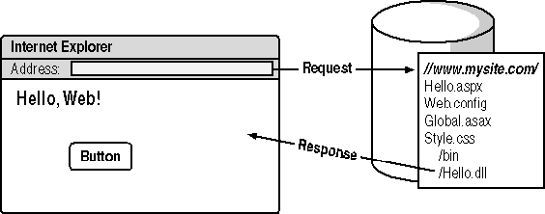
Figure 2-11. Files in a Web application
As shown in Figure 2-11, when a browser requests a page from the application, IIS starts the application’s executable (Hello.dll) and generates a response. In this case, the response is to display the page defined in Hello.aspx. If an event, such as a button click, occurs on the page, it is sent back to the server, where it is handled by the application’s DLL.
The following two lessons cover the details of how events are handled and where processing occurs.
Lesson 2: Responding to Events
In this lesson, you will learn about events in the life cycle of a Web application and how this life cycle is different from the life cycle of a Windows application. Web application events occur at the application, page, and server control levels. The sequence of these events and how they are executed affect how you respond to them in code.
After this lesson, you will be able to
- Understand the sequence of events in an application’s lifetime
- Explain how the events in an application interact
- List the events for each of the major objects in a Web application
- Identify the three different types of server control events
- Use state variables to preserve information in a Web application
Estimated lesson time: 35 minutes
Events in the Life Cycle of a Web Application
A Web application lives as long as it has active sessions, whereas Web forms live for barely a moment. The life of a Web application begins when a browser requests the start page of the application. (See Figure 2-12.) At that point, the Web server swings into action, starting the assembly (DLL) that responds to that request. The executable creates an instance of the requested Web form, generates the HTML to respond to the request, and posts that response to the browser. It then destroys the instance of the Web form.
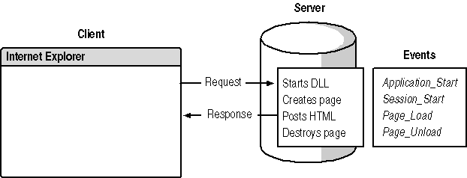
Figure 2-12. Life begins!
When the browser has the generated HTML, the user can type text in boxes, select options, and perform other tasks until triggering a postback event, such as a button click. Postback events cause the browser to send the page’s data (view state) back to the server for event processing. When the server receives the view state, it creates a new instance of the Web form, fills in the data from the view state, and processes any events that occurred. (See Figure 2-13.) As soon as the server has finished, it posts the resulting HTML back to the browser and destroys the instance of the Web form.
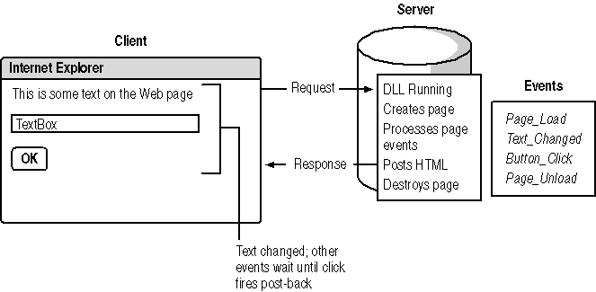
Figure 2-13. Life goes on.
When the user stops using the Web application for a period of time (the default is 20 minutes), the user’s session times out and ends. (See Figure 2-14.) If there are no other sessions from other users, the application ends. This doesn’t always happen right away. The common language runtime (CLR) manages memory using garbage collection rather than reference counting, as OLE did. Garbage collection means that the server periodically traces through the references between objects. When the runtime finds an object that is no longer used, it throws the object away and recovers the memory. This means that you don’t know exactly when an Application_End event will occur.
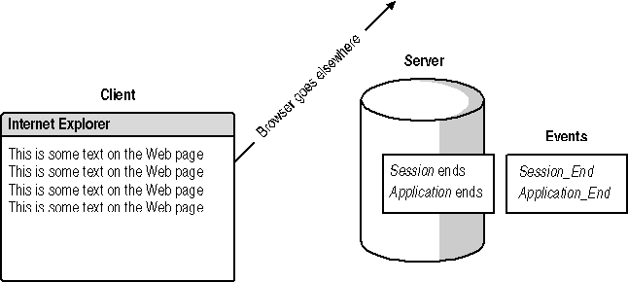
Figure 2-14. This is the end.
Preserving Data on a Web Form
Because Web forms have very short lifetimes, ASP.NET takes special steps to preserve the data entered in the controls on a Web form, as shown in Figure 2-15. Data entered in controls is sent with each request and restored to controls in Page_Init. The data in these controls is then available in the Page_Load event.
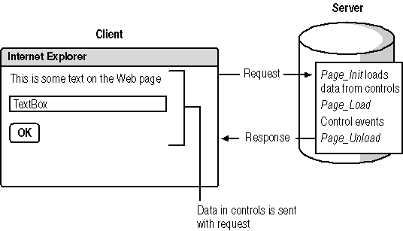
Figure 2-15. ASP.NET preserves Web form data.
The data that ASP.NET preserves between requests is called the Web form’s view state. By default, a Web form’s view state is available only within that Web form. To make data entered on a Web form available to other Web forms in an application, you need to save the data in a state variable in the Application or Session objects. These objects provide two levels of scope:
- Application state variables
These are available to all users of an application. You can think of Application state as multiple-user global data. All sessions can read or write these variables.
- Session state variables
These are available only to a single session (user). Session state is like global data in a standard Windows application. Only the current session has access to its Session state.
Application and Session state variables aren’t declared the way you declare regular variables. Instead, they are created on the fly in code. For example, the following code saves the number of button clicks in Session state:
Visual Basic .NET
Private Sub Button1_Click(ByVal sender As System.Object, _
ByVal e As System.EventArgs) Handles Button1.Click
' Save the number of clicks in Session state.
Session("Clicks") = Session("Clicks") + 1
' Display the number of clicks.
Response.Write("Number of clicks: " & Session("Clicks"))
End Sub
Visual C#
// From Global.asax.cs
protected void Session_Start(Object sender, EventArgs e)
{
// Initialize Clicks Session state variable.
Session["Clicks"] = 0;
}

// From StateNEvents.asax.cs
private void Button1_Click(object sender, System.EventArgs e)
{
// Increment click count.
Session["Clicks"] = (int)Session["Clicks"] + 1;
// Display the number of clicks.
Response.Write("Number of clicks: " + Session["Clicks"] + "<br>");
}
You can save any type of data in a state variable, from a simple integer to whole objects. Because state variables are global data, you need to develop strategies for working with them in your application. Managing state variables in your code is explained in depth in Chapter 3, “Working with Web Objects.”
IMPORTANT
Application state variables must be initialized in Visual C# before you perform most operations on them. For example, you need to assign a value to the Clicks state variable before performing the cast (int)Session["Clicks"]. Otherwise, you will receive the error “Value null was found where an instance of an object was required” at run time.
Application and Session Events
You can write code to respond to Application and Session events in the Global.asax file. Use Application events to initialize objects and data that you want to make available to all the current sessions of your Web application. Use Session events to initialize data that you want to keep throughout individual sessions, but that you don’t want to share between sessions. Table 2-3 lists each of the Application event handlers and describes when they occur.
Table 2-3. Application Event Handlers
Event handler name | Occurs when
Application_Start | The first user visits a page within your Web application.
Application_End | There are no more users of the application.
Application_BeginRequest | At the beginning of each request to the server. A request happens every time a browser navigates to any of the pages in the application.
Application_EndRequest | At the end of each request to the server.
Session_Start | A new user visits a page within your application.
Session_End | A user stops requesting pages from the Web application and their session times out. Sessions time out after a period specified in the Web.config file.
In Web forms, a session is a unique instance of the browser. A single user can have multiple instances of the browser running on his or her machine. If each instance visits your Web application, each instance has a unique session.
To see how Application and Session events occur, add the following code to the Global.asax file in a Web forms project:
Visual Basic .NET
Sub Application_Start(ByVal Sender As Object, ByVal E As EventArgs)
' Record application start.
Application("AppCount") = Application("AppCount") + 1
End Sub

Sub Session_Start(ByVal Sender As Object, ByVal E As EventArgs)
' Count sessions.
Application("SessCount") = Application("SessCount") + 1
' Display Application count.
Response.Write("Number of applications: " & _
Application("AppCount") & "<br>")
' Display session count.
Response.Write("Number of sessions: " & _
Application("SessCount") & "<br>")
End Sub

Sub Session_End(ByVal Sender As Object, ByVal E As EventArgs)
' Decrement sessions.
Application("SessCount") = Application("SessCount") - 1
End Sub
Visual C#
protected void Application_Start(Object sender, EventArgs e)
{
// Create Application state variables.
Application["AppCount"] = 0;
Application["SessCount"] = 0;
// Record application start.
Application["AppCount"] = (int)Application["AppCount"] + 1;
}

protected void Session_Start(Object sender, EventArgs e)
{
// Count sessions.
Application["SessCount"] = (int)Application["SessCount"] + 1;
// Display Application count.
Response.Write("Number of applications: " +
Application["AppCount"] + "<br>");
// Display session count.
Response.Write("Number of sessions: " +
Application["SessCount"] + "<br>");
}

protected void Session_End(Object sender, EventArgs e)
{
// Decrement sessions.
Application["SessCount"] = (int)Application["SessCount"] - 1;
}
To demonstrate the events, run the preceding code, and then start a new instance of the browser and navigate to the address. Each new instance of the browser increments the session count, but the application count stays at 1.
It’s important to realize that intrinsic objects such as Session and Response are not available at Application_Start. To use these objects, you have to wait until their creation event occurs.
Web Form Events
You use Web form events to process and maintain data used on a Web page, to respond to data binding, and to handle exceptions on the Web page. Table 2-4 lists the events that occur on a Web form; the first five events are shown in order of occurrence.
Table 2-4. Web Form Events
Event handler name | Occurs when
Page_Init | The server controls are loaded and initialized from the Web form’s view state. This is the first step in a Web form’s life cycle.
Page_Load | The server controls are loaded in the Page object. View state information is available at this point, so this is where you put code to change control settings or display text on the page.
Page_PreRender | The application is about to render the Page object.
Page_Unload | The page is unloaded from memory.
Page_Disposed | The Page object is released from memory. This is the last event in the life of a Page object.
Page_Error | An unhandled exception occurs.
Page_AbortTransaction | A transaction is aborted.
Page_CommitTransaction | A transaction is accepted.
Page_DataBinding | A server control on the page binds to a data source.
You can couple the Page_Load event with the IsPostback property to initialize data the first time a user visits a Web form. This is similar to a Session_Start event; however, it occurs at the page level rather than the application level. The following code initializes an object and stores it in the Session state the first time a page is viewed:
Visual Basic .NET
' Declare a new object.
Dim FlashCard As New FlashCardClass()

Private Sub Page_Load(ByVal sender As System.Object, _
ByVal e As System.EventArgs) Handles MyBase.Load
' If this is the first time the page is viewed...
If Not (Page.IsPostBack) Then
' Shuffle the FlashCards.
FlashCard.Shuffle()
' Store the object in a Session variable.
Session("FlashCard") = FlashCard
End If
' Get the Session FlashCard variable.
FlashCard = Session("FlashCard")
RefreshDisplay()
End Sub
Visual C#
// From the Web Form Designer generated code region.
private void InitializeComponent()
{
this.Load += new System.EventHandler(this.Page_Load);
}

// Declare a new object.
FlashCardClass FlashCard = new FlashCardClass();

private void Page_Load(object sender, System.EventArgs e)
{
if(!IsPostBack)
{
// Shuffle the FlashCards.
FlashCard.Shuffle();
// Store the object in a Session variable.
Session["FlashCard"] = FlashCard;
}
// Get the Session FlashCard variable.
FlashCard = (FlashCardClass)Session["FlashCard"];
RefreshDisplay();
}
The other page events let you customize the appearance of the page and respond to data events. Data binding, transaction processing, and rendering are covered in greater detail in subsequent chapters.
Server Control Events
Server controls, such as a Button, TextBox, and DropDownList, each have their own sets of events that occur in response to user actions. However, not all server control events are created equal. There are three types of server control events:
- Postback events
These events cause the Web page to be sent back to the server for immediate processing. Postback events affect perceived performance because they trigger a round-trip to the server.
- Cached events
These events are saved in the page’s view state to be processed when a postback event occurs.
- Validation events
These events are handled on the page without posting back or caching. The validation server controls use these types of events.
Figure 2-16 shows the sequence of server control events on a Web form. The validations controls are evaluated before the page is posted back to the server. When the page is posted back, the Page_Init and Page_Load events are handled, then cached events are handled, and finally the event that caused the postback is processed. Among cached events, the event order is determined by the order of the controls on the Web form.
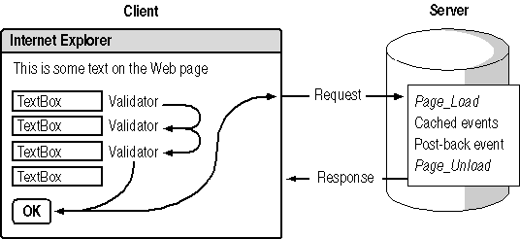
Figure 2-16. A Web form’s sequence of events
The Button, Link Button, and Image Button controls all cause postback events. The TextBox, DropDownList, ListBox, RadioButton, and CheckBox controls provide cached events; however, you can override this behavior by setting the AutoPostBack property to True.
To see how validation, cached, and postback events interact, create a Web form with a TextBox control, a RequiredFieldValidator control, and a Button control. Set the ControlToValidate property of the validator control to TextBox1, and then add the following code to the TextBox and Button event handlers:
Visual Basic .NET
Private Sub Button1_Click(ByVal sender As System.Object, _
ByVal e As System.EventArgs) Handles Button1.Click
Response.Write("Button Clicked!<br>")
End Sub

Private Sub TextBox1_TextChanged(ByVal sender As Object, _
ByVal e As System.EventArgs) Handles TextBox1.TextChanged
Response.Write("Text has changed!<br>")
End Sub
Visual C#
private void Button1_Click(object sender, System.EventArgs e)
{
Response.Write("Button Clicked!<br>");
}

private void TextBox1_TextChanged(object sender, System.EventArgs e)
{
Response.Write("Text has changed!<br>");
}

// From the Web Form Designer generated code region.
private void InitializeComponent()
{
this.Button1.Click += new System.EventHandler(this.Button1_Click);
this.TextBox1.TextChanged += new EventHandler(this.TextBox1_TextChanged);
this.Load += new System.EventHandler(this.Page_Load);
}
If you leave the TextBox control blank and click OK, the RequiredFieldValidator control is displayed—no other events are processed and the page is not posted back to the server. If you type text in the TextBox control and click OK, the page is posted back and the TextChanged event occurs before the Click event.
Lesson 3: Where Does Processing Occur?
As you know from the previous lesson, Web applications run on a server. But Web applications aren’t like Windows applications, which start when the user invokes an executable file and end when the user closes the application. Instead, Web applications start when a browser requests a Web page and end when no more requests are made.
After this lesson, you will be able to
- Use folder structure to define the boundaries of an application
- Set a start page for your application in Visual Studio and set a default document for your application in IIS
- Explain how ASP.NET manages application processes
- Set the time-out value that indirectly determines when an application ends
Estimated lesson time: 15 minutes
Application Boundaries and Start Pages
IIS defines a Web application as any file that is executed within a set of folders on your Web site. The boundaries of a Web application are determined by its folder structure. The application boundary starts in the root application folder, which contains the application’s start page, its Web.config file, and the /bin folder containing the application’s assembly. The application ends at the last subordinate folder or when another root application folder is encountered. Figure 2-17 shows several separate applications.
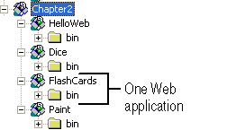
Figure 2-17. Web application boundaries in IIS
When Visual Studio .NET creates a new Web application project, it creates a new folder for the project and identifies the first Web form in the project (Webform1.aspx) as the start page. A start page is a page designated by Visual Studio as the first page to display in your application. All of the subordinate folders, such as /bin, are part of that application.
If your application design changes during development, or if you just want to quickly run the current page during debugging, you might want to change the start page of your application.
To set a different Web form or HTML page as the start page, do the following:
- In Solution Explorer, right-click the Web form or HTML page you want to specify as the start page of your application, and choose Set As Start Page on the shortcut menu.
When you are ready to deploy your Web application, you will usually want to set the application’s start page as its default document in IIS. The IIS default document is the page that IIS displays if the user omits the document name as part of his or her requested address. By default, IIS specifies these default document file names: Default.htm, Default.asp, Index.htm, and Iisstart.asp.
To set your application’s start page as the default document in IIS, either rename the start page to one of the file names in the preceding list, or add the start page’s file name to the IIS default document list by following these steps:
- In the IIS management console, select the Web application in the console tree, and the choose Properties from the Action menu. The Web site’s Properties dialog box opens.
- On the Documents tab of the Properties window, click Add. The Add Default Document dialog box opens and allows you to add the name of your application’s start page to the default document list, as shown in Figure 2-18.
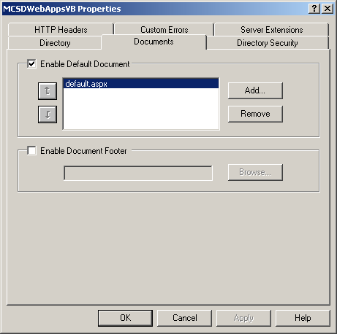
Figure 2-18. The Add Default Document dialog box
- In the Add Default Document dialog box, type the name of your document and click OK. Click OK to close the Web site’s Properties window.
The order of the file names shown in Figure 2-18 determines the precedence of default documents. IIS checks for these documents in the order shown and displays the first document that matches.
How IIS and ASP.NET Manage Processes
Understanding application boundaries is important because ASP.NET uses these boundaries to determine how your application is run on the server. When IIS receives a request for a resource within a Web application, IIS uses aspnet_isapi.dll to call the ASP.NET worker process (aspnet_wp.exe). The ASP.NET worker process loads the Web application’s assembly, allocating one process space, called the application domain, for each application.
In this way, ASP.NET maintains process isolation for each Web application. This is different from the way IIS provided different isolation levels for older Active Server Pages (ASP) applications running under DLLHost.exe. The isolation level settings in IIS have no effect on ASP.NET applications.
In IIS version 6.0, you will be able to configure multiple application pools, each of which can be served by one or more process instances (w3wp.exe). In addition, ASP.NET is integrated with the IIS version 6.0 kernel mode HTTP listener, which will allow requests to pass directly from the operating system to the ASP.NET worker process. For more information about IIS version 6.0, see the TechNet article http://www.microsoft.com/technet/prodtechnol/iis/evaluate/iis6ovw.asp.
Determining When an Application Ends
When a user requests a page from a Web application for the first time, IIS starts the Web application, if it is not already running, and creates a session for that user. All of the subsequent requests made by that user are part of the same session. Sessions are important for two reasons:
- They allow ASP.NET to keep user-specific data called the Session state. Session state and Application state are explained in Lesson 2.
- They determine when the application ends. When the last session ends, IIS ends the application.
How long a session lasts is determined by a time-out value set in your project’s Web.config file. The default is 20 minutes. That means that 20 minutes after a user makes his or her last request to an application, the user’s session ends. When there are no more sessions, the application ends.
Remember that IIS defines a Web application as any file that is executed within a set of folders on your Web site. So if a user requests any of the .aspx files in that application’s set of folders within 20 minutes, that user’s session is maintained.
NOTE
You have only indirect control over when an application ends through the session time-out. It is important to understand this because the session timeout controls the life cycle of the application on the server.
Reducing the session time-out value can free up resources on the server because session data expires more quickly. However, setting the value too low can cause sessions to time out while they are still being used.
To change the session time-out value, follow these steps:
- Open the project in Visual Studio .NET.
- Open the Web.config file by double-clicking it in the Solution Explorer window.
- Edit the time-out value (shown in boldface) in the following line in the file:
- <sessionState mode="InProc" stateConnectionString="tcpip=127 .0.0.1:42424"
- sqlConnectionString="data source=127.0.0.1;use r id=sa;password="
cookieless="false" timeout="20" />
- Save the file.
Any changes to the Web.config file automatically restart the Web application. If you change the Web.config file on a deployed Web application, Application state and Session state variables are lost for any current users.
Summary
- Web applications use Web forms to create a user interface that is presented through an Internet browser on the user’s computer.
- The code and resources that respond to events and perform useful tasks reside and run on the Web server hosting the application.
- Because Web applications are distributed between a client and a server, there are five significant differences between programming for the Web and programming for Windows:
  - Web applications use server controls and HTML controls rather than Windows controls.
  - Web applications are displayed in a Web browser rather than in their own window.
  - Web forms are not persistent while displayed. You must preserve persistent data in a state variable during page and control events.
  - Processing occurs on the server, and data is exchanged through a cycle of requests and responses.
  - Web applications are event-driven, and events occur at the application, page, and server control levels.
- Server control events have three types, which occur in the following order:
  - Validation events occur before the page is returned to the server.
  - Cached events are collected while the page is displayed and then processed once the page sends a request to the server.
  - Postback events cause the page to send a request to the server, but their event procedure is processed last in order of events handled.
- The boundaries of a Web application are determined by its folder structure.
- Application boundaries affect the scope of data stored in Application state.
- You use IIS to create root folders for your applications, set application boundaries, and determine the process in which IIS runs your application.
Lab: Building a Simple Web Application
In this lab, you will create the FlashCards application. FlashCards is a simple, one-form Web application that displays math problems and evaluates the entered result—just like the flash cards used in an elementary-school math class.
To complete the FlashCards application, you will create a Web form, add server controls to the form, and control those server controls from the Page_Load event procedure. The completed Web form will look like Figure 2-19.
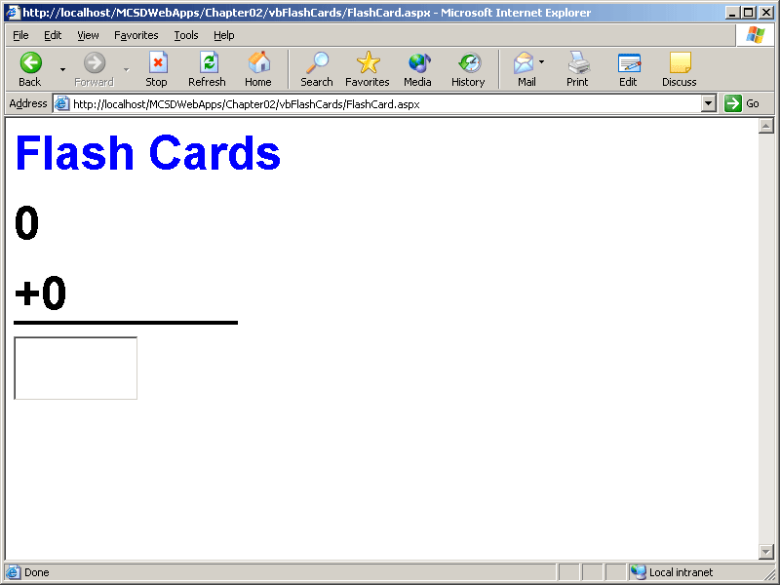
Figure 2-19. The completed FlashCard Web form
Estimated lesson time: 20 minutes
Exercise 1: Create the User Interface

In this exercise, you will start the FlashCards project and create the user interface by adding server controls to the FlashCard Web form.
To create a new Web application project
- On the File menu of Visual Studio .NET, point to New and choose Project. In the New Project dialog box, select ASP.NET Web Application, change the path in the Location box to end with FlashCards, and click OK.
- In the Properties window, change the name of the WebForm1.aspx file to FlashCard.aspx.
To add the controls to the user interface
Add server controls to the Web form, as shown in Figure 2-19, and define the following properties:
Control | Control type | Property | Value
Label1 | Label | ID | lblFeedback
 |  | Font | Arial, Bold, XXL
 |  | Text | Flash Cards
Label2 | Label | ID | lblFirst
 |  | Font | Arial, Bold, XXL
Label3 | Label | ID | lblSecond
 |  | Font | Arial, Bold, XXL
<HR> | Horizontal Rule | Size | 4
 |  | Color | #000000
TextBox1 | Text Box | ID | txtAnswer
 |  | AutoPostBack | True
 |  | Font | Arial, Bold, XXL
TIP
If you want to create several controls with similar properties, create the first control, set its properties as desired, and then copy and paste to create new controls with the same properties. In Web forms, this does not create a control array as it does in Windows forms.
Exercise 2: Create a Class Named FlashCardClass
In this exercise, you will create a class to contain the logic and data that the FlashCards application uses. A class is a definition of an object used to perform a task in a program. Chapter 3, “Working with Web Objects,” has more information about object-oriented programming.
The FlashCardClass class created here generates random math problems to display on the Web form. This is the logic that the application uses. In this application, and in most Web form applications, the logic (FlashCardClass) is separated from the user interface (the Web form).
To create a class
- From the Project menu, choose Add Class. Visual Studio .NET displays the Add New Item dialog box. Name the class FlashCardClass, and click Open.
- In the Code window, add the following code:
Visual Basic .NET
Public Class FlashCardClass

Dim mintFirstNumber, mintSecondNumber As Integer
Dim mstrOp As String = "+"
Dim mrndNumber As Random

Public Sub New()
' Initialize the random number generator object.
mrndNumber = New Random()
End Sub

Public Sub Shuffle(Optional ByVal Min As Integer = 1, _
Optional ByVal Max As Integer = 12)
' Get random numbers.
mintFirstNumber = mrndNumber.Next(Min, Max)
mintSecondNumber = mrndNumber.Next(Min, Max)
End Sub

Public ReadOnly Property FirstNumber()
Get
FirstNumber = mintFirstNumber
End Get
End Property

Public ReadOnly Property SecondNumber()
Get
SecondNumber = mintSecondNumber
End Get
End Property

Public Property Operation() As String
Get
Operation = mstrOp
End Get
Set(ByVal Value As String)
mstrOp = Value
End Set
End Property

' Calculates answer based on current operation.
Public Function Answer() As Integer
Select Case mstrOp
Case "+"
Answer = mintFirstNumber + mintSecondNumber
Case "x", "*"
Answer = mintFirstNumber * mintSecondNumber
Case "-"
Answer = mintFirstNumber - mintSecondNumber
End Select
End Function

End Class
Visual C#
public class FlashCardClass
{
int mintFirstNumber, mintSecondNumber;
string mstrOp = "+";
Random mrndNumber;

public FlashCardClass()
{
// Initialize the random number generator object.
mrndNumber = new Random();
}

public void Shuffle(int Min, int Max)
{
// Get random numbers.
mintFirstNumber = mrndNumber.Next(Min, Max);
mintSecondNumber = mrndNumber.Next(Min, Max);
}

// Shuffle with no parameters defaults to Min = 0, Max = 12.
public void Shuffle()
{
// Get random numbers.
mintFirstNumber = mrndNumber.Next(0, 12);
mintSecondNumber = mrndNumber.Next(0, 12);
}

public int FirstNumber
{
get
{
return mintFirstNumber;
}
}

public int SecondNumber
{
get
{
return mintSecondNumber;
}
}

public string Operation
{
get
{
return mstrOp;
}
set
{
mstrOp = value;
}
}

// Calculates answer based on current operation.
public int Answer()
{
switch(mstrOp)
{
case "+":
return mintFirstNumber + mintSecondNumber;
case "x":
return mintFirstNumber * mintSecondNumber;
case "*":
return mintFirstNumber * mintSecondNumber;
case "-":
return mintFirstNumber - mintSecondNumber;
default :
return 0;
}
}

}
Exercise 3: Store a FlashCardClass Object in Session State
In this exercise, you will add code to initialize a Session state variable containing the FlashCardClass object that your Web form will use. The FlashCardClass is stored in a Session variable, so it is retained during the user’s session.
To create a Session state variable
- In the Code View window for the Web form FlashCard.aspx, add the following code to the Page_Load event procedure:
Visual Basic .NET
' FlashCard.aspx.vb
Dim FlashCard As FlashCardClass

Private Sub Page_Load(ByVal sender As System.Object, _
ByVal e As System.EventArgs) Handles MyBase.Load
' Create a Session FlashCard object the first time page displays.
If Not IsPostBack Then
' Create a new FlashCard object
FlashCard = New FlashCardClass
' Store the object in a Session variable.
Session("FlashCard") = FlashCard
Else
' Get the Session FlashCard object.
FlashCard = Session("FlashCard")
End If
RefreshDisplay()
End Sub
Visual C#
// FlashCard.aspx.cs
FlashCardClass FlashCard;

private void Page_Load(object sender, System.EventArgs e)
{
// Run the following code the first time the page is displayed.
if(!IsPostBack)
{
FlashCard = new FlashCardClass();
Session["FlashCard"] = FlashCard;
}
else
{
// Get the Session FlashCard object.
FlashCard = (FlashCardClass)Session["FlashCard"];
}
RefreshDisplay();
}
Exercise 4: Use the FlashCardClass Object from Web Form Events
In this exercise, you will add code to the Web form to use the FlashCardClass object stored in the Session state variable. This links the logic (FlashCardClass) to the user interface (FlashCard.aspx).
To use the FlashCardClass object from event procedures in the Web form
- In the Design window, double-click the TextBox control to automatically create the event procedure and wire the TextChanged event. Add the following code to the Text_Changed event procedure:
Visual Basic .NET
Private Sub txtAnswer_TextChanged(ByVal sender As System.Object, _
ByVal e As System.EventArgs) Handles txtAnswer.TextChanged
If txtAnswer.Text = FlashCard.Answer Then
lblFeedback.Text = "Correct!"
' Get another set of numbers.
FlashCard.Shuffle()
' Refresh display to show new numbers.
RefreshDisplay()
' Clear answer
txtAnswer.Text = ""
Else
lblFeedback.Text = "Oops! Try Again."
End If
End Sub
Visual C#
private void txtAnswer_TextChanged(object sender, System .EventArgs e)
{
if(txtAnswer.Text == FlashCard.Answer().ToString())
{
lblFeedback.Text = "Correct!";
// Get another set of numbers.
FlashCard.Shuffle();
// Refresh display to show new numbers.
RefreshDisplay();
// Clear answer
txtAnswer.Text = "";
}
else
{
lblFeedback.Text = "Oops! Try Again.";
}
}

// From the Web Form designer generated code region (create automatically
// when you double-click the TextBox control.
private void InitializeComponent()
{
this.txtAnswer.TextChanged += new
System.EventHandler(this.txtAnswer_TextChanged);
this.Load += new System.EventHandler(this.Page_Load);
}
- In the WebForm1 class, add the following helper procedure to refresh the labels on the display:
Visual Basic .NET
Private Sub RefreshDisplay()
lblFirst.Text = FlashCard.FirstNumber
lblSecond.Text = FlashCard.Operation & _
FlashCard.SecondNumber
End Sub
Visual C#
private void RefreshDisplay()
{
lblFirst.Text = FlashCard.FirstNumber.ToString();
lblSecond.Text = FlashCard.Operation +
FlashCard.SecondNumber.ToString();
}
- Run and test the application.
TIP
Using a form-level variable to hold data stored in Session or Application state variables, as shown in steps 2 and 3, helps you catch errors. Visual Studio .NET does not require you to declare state variables. Misspelling a state variable name simply creates a new, empty state variable.
Review
The following questions are intended to reinforce key information presented in this chapter. If you are unable to answer a question, review the appropriate lesson and then try the question again. Answers to the questions can be found in the appendix.
- Explain where Visual Studio .NET stores Web application projects.
- List the four major differences between Web and Windows applications.
- Describe the life cycle of a Web application: When are Web forms instantiated and how long do they exist?
- How do you preserve persistent data, such as simple variables, in a Web application?
- What determines the boundaries of a Web application?

